**Types of Routing**

Routing is a process that is performed by layer 3 (or network layer) devices in order to deliver the packet by choosing an optimal path from one network to another.

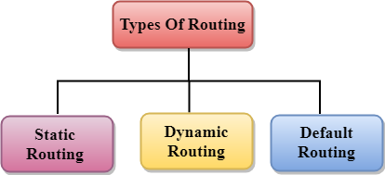

**1. Static routing:**

It is a technique in which the administrator manually adds the routes in a routing table.

**Advantages:**

* **No Overhead:** No routing overhead for router CPU which means a cheaper router can be used to do routing.
* **Security:** It adds security because an only administrator can allow routing to particular networks only.
* **Bandwidth:** No bandwidth usage between routers.

**Disadvantage:**

* For a large network, it is a hectic task for administrators to manually add each route for the network in the routing table on each router.
* The administrator should have good knowledge of the topology. If a new administrator comes, then he has to manually add each route so he should have very good knowledge of the routes of the topology.

**2. Default Routing:**

This is the method where the router is configured to send all packets towards a single router (next hop). It doesn’t matter to which network the packet belongs, it is forwarded out to the router which is configured for default routing. It is generally used with stub routers. A stub router is a router that has only one route to reach all other networks.

**3. Dynamic Routing:**

Dynamic routing makes automatic adjustments of the routes according to the current state of the route in the routing table. Dynamic routing uses protocols to discover network destinations and the routes to reach them. RIP and OSPF are the best examples of dynamic routing protocols. Automatic adjustments will be made to reach the network destination if one route goes down.

A dynamic protocol has the following features:

* The routers should have the same dynamic protocol running in order to exchange routes.
* When a router finds a change in the topology then the router advertises it to all other routers.

**Advantages:**

* Easy to configure.
* More effective at selecting the best route to a destination remote network and also for discovering remote network.

**Disadvantage:**

* Consumes more bandwidth for communicating with other neighbours.
* Less secure than static routing.